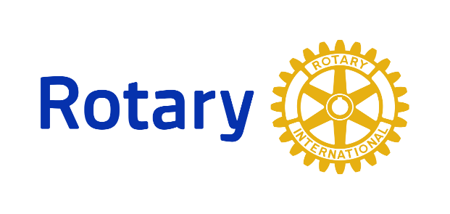

District 7255 Interact and Rotaract Programs
___________________________________________________________________

What is Interact? Interact clubs bring together young people ages 12-18 to develop leadership skills while discovering the power of Service Above Self. Interact Clubs organize at least two projects every year, one that helps their school or community and one that promotes international understanding. Rotary Club sponsors mentor and guide Interactors as they carry out projects and develop leadership skills.
How do I join? Check with your school or contact Rotary District 7255’s Interact Chair warrensternberg1@gmail.com to find out if there’s an interact club in your area.

