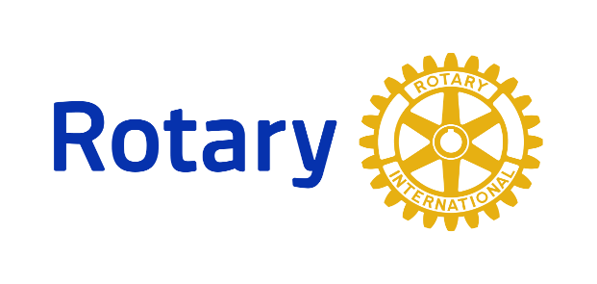

District 7255 Interact and Rotaract Programs
___________________________________________________________________
What is Rotaract? Rotaract Clubs bring together people ages 18 and older to exchange ideas with leaders in the community, develop leadership and professional skills, and have fun through service. Rotary and Rotaract members work side y side to take action through service. Rotary club sponsors offer guidance and support and work with Rotaract Clubs as partners in service.
How do I join? Contact Rotary District 7255’s Rotaract Chair, warrensternberg1@gmail.com to find a out if there’s a Rotaract club in your area.

