IMMEDIATE PAST INTERNATIONAL CHAIR
PRID DAVID LINETT
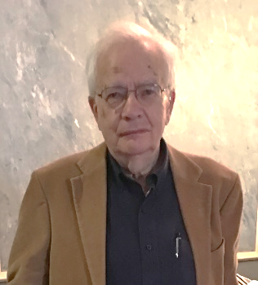

My Dear Friends and Colleagues,
It is with mixed emotions that I have decided to step down as International Chair of RLI. I first announced the formation of a Rotary Leadership program when I was the District Governor for my former District 7510 in New Jersey, USA. I mailed a letter to our clubs in December 1991. It is hard for me to realize how many years have passed and how now RLI has grown into a substantial district program in more than 400 plus Rotary districts in every continent of the world.

INTERNATIONAL CHAIR
PRIVP MICHAEL J. MCGOVERN
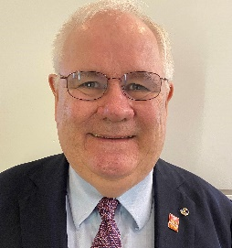
Mike joined Rotary in 1986 as a member of the Rotary Club of South Portland-Cape Elizabeth, Maine, USA. He served as club president, district governor, district foundation chair, Council on Legislation delegate, Rotarian Action Group chair, international training leader, Institute convener, RI committee member and chair, trustee and vice chair of the Rotary Foundation, and director and vice president of Rotary International. Mike has spoken at events representing Rotary in 37 states, 8 Canadian provinces, and 34 countries.
He is the chair of the Rotary Leadership Institute, an independent association of Rotary districts. He began serving RLI as a faculty member in 2001 and served as chair of RLI in the Northeast America (Home) Division in 2004-2006. He was a recipient of the RLI Distinguished Award in 2014.
Mike McGovern has served as the Chair of Rotary International’s PolioPlus Committee since October 2014. In this role, he is the volunteer leader of Rotary’s largest humanitarian project, the global eradication of polio. Rotary is the spearheading partner of the Global Polio Eradication Initiative and has donated over $2.0 billion to ending polio and has worked with other partners to reduce the number of polio endemic countries from 125 in 1988 to 2 today. Mike represents Rotary on the Polio Oversight Board.

RLI NORTH EAST AMERICA CHAIR
PDG PAUL F. MUCZYZNSKI

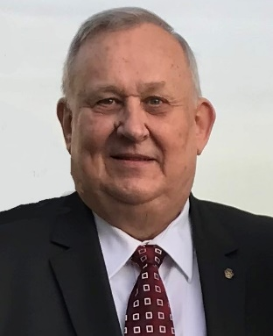
It is hard to imagine I am entering my third year as the RLI NEA Chair. The past two years have been enjoyable, but challenging. In the first year we implemented the DACdb program. The implementation went rather smoothly. The second year was much improved. This was made possible by the dedication of the Regional Vice Chairs. Also, as in any organization there is always someone behind the scenes who sees to it that everything runs as planned. In RLI NEA we have such a person, namely out-going Executive Director Tom Fletcher. I do not know if the DACdb implementation would have gone so smoothly without Tom’s long hours and dedication.
The end of the second year was quite different. The Covid-19 pandemic struck. The District Governors of four districts made the hard decision to cancel their sites. In addition, we make the decision to cancel our August Annual meeting. We are now at the point with the pandemic where we were hoping to be able to offer all sites as scheduled. However, a decision was made to only offer online sessions.

RLI NORTH EAST AMERICA CHAIR 2021-24
PDG GERALD GORTNER

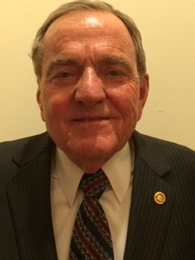
Jerry Gortner has been selected to be our RLINEA Chair for 2021-24. Jerry joined the Rotary Club of Canastota in 1983 and was Governor of District 7150 in 2005-06. He has been a qualified facilitator since 2006 and is also a Graduate facilitator. Jerry has served RLINEA as a Regional Vice Chair, Vice Chair North, and Treasurer. Professionally he was with Ameriprise Financial services for 43 years during which he served in the compliance department for five years, was a District manager, trainer, and financial advisor. Jerry is originally from Ohio where he graduated from Ohio State University. Following graduation, he was employed by the USDA in Ohio, New England, and New York. He is also a charter member of the Arlington, Massachusetts Jaycees and was President of the 14,000 member New York State Jaycees.

2020 YVETTE PALMER AWARD RECIPIANT
GREGORY ROCHE
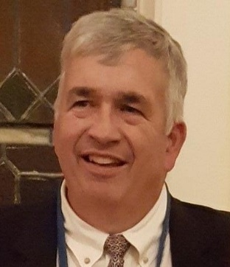

The Yvette Palmer Award is named in honor and memory of Yvette Palmer, a strong supporter of the Rotary Leadership Institute
Greg Roche progressed from RLI student to facilitator in 2007, in his DG year. When he accepted his first assignment, instead of leading 1 or 2 sessions, he was assigned 4 because other facilitators were absent. He accepted this challenge and was a successful first-time discussion leader. Greg has been an effective and well received discussion leader ever since.
Greg started his administrative life with RLI by becoming Regional Vice-Chair for southern New England. He managed 5 sites during his 3-year tenure, maintaining or improving participation and mentoring newly minted facilitators in this area. During the last year of his assignment, he had identified his successor and had himself shadowed, to provide a smooth transition.
Greg’s work life experience with IT/Project Management made him the perfect choice for his next assignment. The Executive Director position is the most detail-oriented job in RLINEA, and Greg was ideally suited for this. During his 3-year tenure, he launched the search to replace the in-house supported database with an off-the-shelf version. DACdb was chosen as the provider and the transition was begun.
Finally, instead of having a cigar and a Scotch on his deck, he then became the Treasurer for RLINEA. As well as tracking all the assets of RLI and producing all the necessary documents, he never let the sun set on a reimbursement request…Very refreshing.

2020 FACILITATOR OF THE YEAR
BERNADETTE KUCHARCZUK
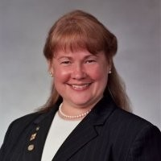

Paulette Boudrot nominated Bernadette for Facilitator of the year. Paulette wrote, “I first met Bernadette when I was RVC for Southern New England during the 2017-2018 Rotary year. I was surprised she had traveled such a great distance to facilitate at the Wakefield, MA site. I was even more surprised and impressed as I sat in on a presentation. She was knowledgeable about Rotary, presented the material in an innovative way, was enthusiastic and used positive and unique reinforcement techniques that involved all participants in a joyful and engaging manner. Furthermore, she is always smiling; even her frown looks like a smile.
Bernadette volunteered at other sessions where I was either RVC or on the faculty. Her evaluations repeatedly were 5s and 4s and contained words such as engaging, personable, fun, knowledgeable, visuals, best session, etc. You knew that Bernadette and her husband/gopher/assistant would always be at the faculty dinner on Friday night ready to share their experiences from all over the RLI NEA area where she had facilitated. You could also count on Bernadette to be at the Annual Meeting every year where she was an eager participant, sharing her “Tips & Tricks” for facilitating. When a call went out for more volunteers to facilitate Graduate Courses, Bernadette took the training and jumped right in.”

RLI NORTHEAST AMERICA
EXECUTIVE DIRECTOR
PDG DEBORAH A. GLISSON

Deb was born and raised in Camillus, New York. She became an active member of the Rotary Club of Marcellus, New York, in 2004. Deb served as Club President in 2007-2008, the 50th anniversary year for the club. She became the Assistant Governor for Rotary District 7150 Area 7 in July 2009. Deb was the District Governor of District 7150 in 2014-2015. Following her Governor year, Deb served a three-year term as the District Membership Chair. She has served as district trainer for two District Governors. Currently, Deb is serving as the Chair of the Empire MD PETS and as a second term representative to the Rotary International Counsel on Resolutions and Legislation.
Deb was trained as a faculty member for the Rotary Leadership Institute in August 2010. Since then, she has facilitated at several RLI sights each spring and fall. Deb has served RLI NEA as District 7150 Site Chair, Regional Vice Chair, Vice Chair Northern Areas and now looks forward to her tenure as Executive Director.
As a retired School and District Administrator with 45 years in the profession, Deb believes in supporting the endeavors of all life-long learners. She has shared her expertise throughout the United States, The United Kingdom, Central America and South America.

BRANDING
As many of you know Rotary International has asked International Rotary Leadership Institute to reinforce their branding rules in regard to our RLI program,
A - We will be replacing the traditional wheel in our logo with the world globe It looks really nice by the way and quite appropriate especially since we’re a worldwide program. We have requested time to use up the current quantity of pins and printed materials with the old logo. The new logo can be downloaded from the RLI files website rlifiles.com.
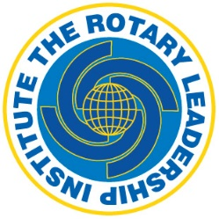
B - With the wording, Rotary Leadership Institute, we must include an identifying name, i.e. District, or Location. Using just Rotary Leadership Institute is unacceptable.
C - All subsequent printed materials, websites, etc., we agree to clearly state the following disclaimer:
“RLI is a multi-district, grassroots leadership development program of member Rotary districts organized into regional divisions in various parts of the world. It is not an official training program of Rotary International”

PLEASE BE AWARE…..
ON SATURDAY, SEPTEMBER 26, 2020, A PILOT RLI VIRTUAL EVENT WILL BE HOSTED BY THE VERONA RLI SITE. THIS IS YOUR OPPORTUNITY TO EXPERIENCE THE FIRST VIRTUAL RLI EVENT. IT IS SCHEDULED TO RUN FROM 9:00 AM UNTIL 2:00 PM. WITH BREAKS THROUGHOUT! THE COST FOR THIS EVENT HAS BEEN GREATLY REDUCED TO $25.00! PLEASE REGISTER AT www.rlinea.org

